**COMPUTER SYSTEMS AND PROGRAMING**

**(Lab manual-8)**

**NAME:** SAMEEN WASEEM

**BATCH:** ME-15

**SECTION:** A

**CMS ID:** 465064

**SUBMITTED TO:**

**COURSE INSTRUCTOR:** DR MUHAMMAD JAWAD KHAN

**LAB INSTRUCTOR:** SIR MUHAMMAD AFFAN



**TASK-1:**

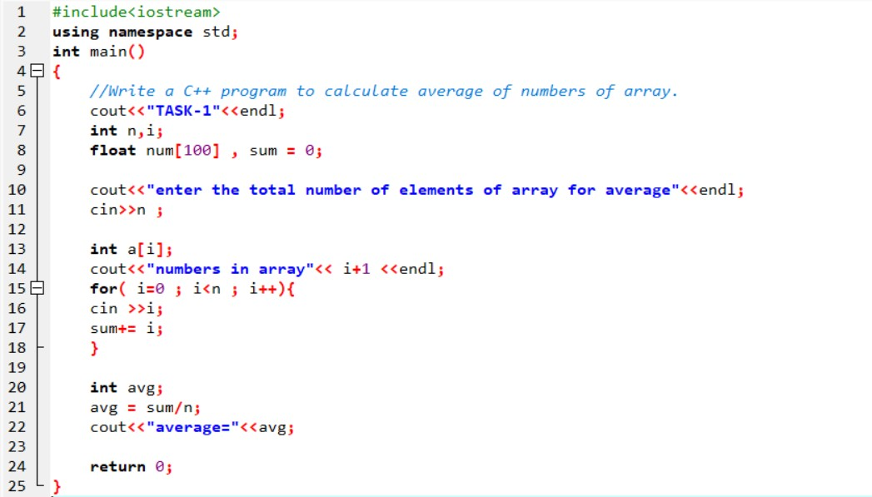

**OUTPUT:**

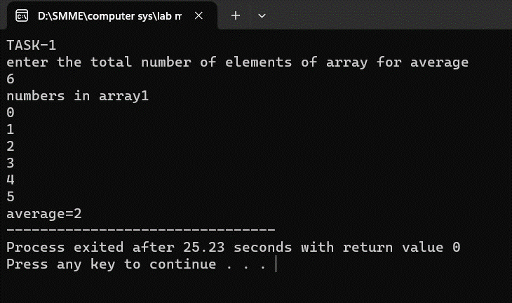

**TASK-2:**

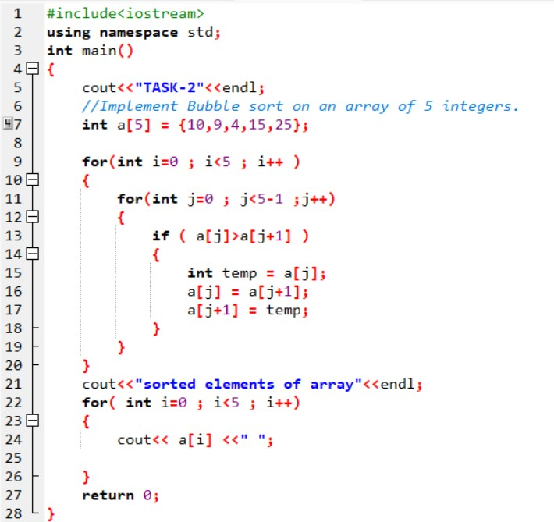

**OUTPUT:**

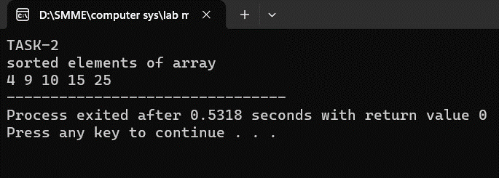

**TASK-3:**

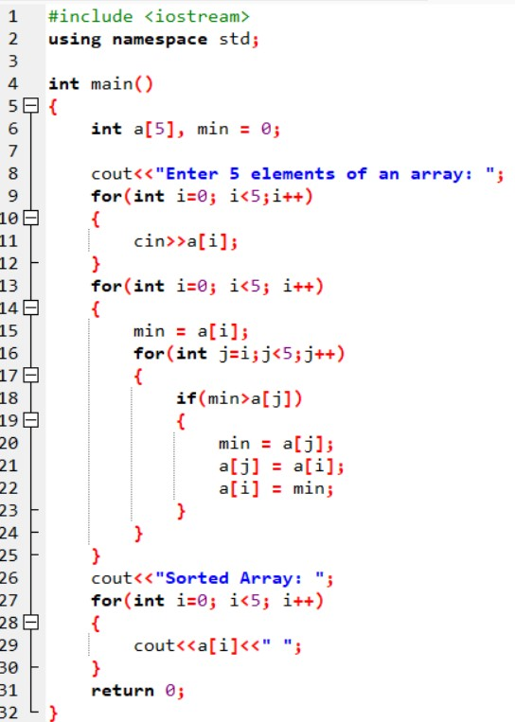

**OUTPUT:**

